

Lab TASK 1

CS 5-1 - BSCS – Operating System Lab

Name: Sharaiz Ahmed SAP: 57288

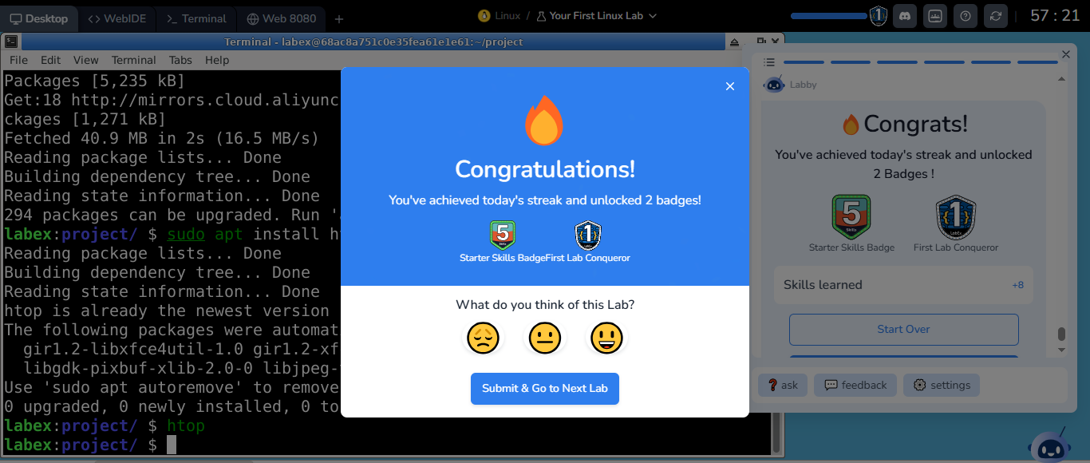
I’ve run my first few commands on linux to display a string and also to install htop software.

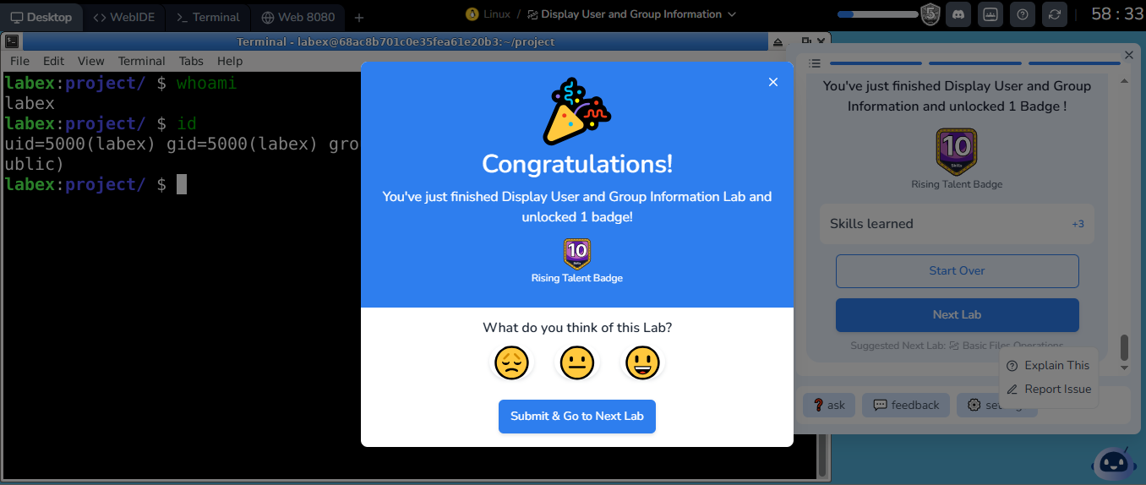
I have successfully completed the "Display User and Group Information" challenge.

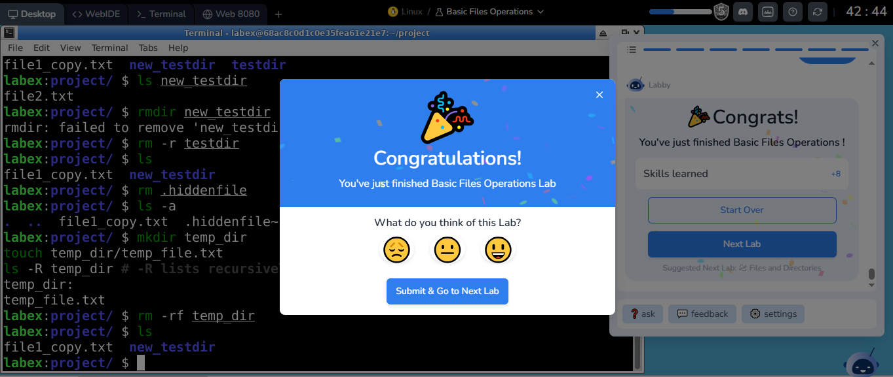
I’ve performed some commands to make new files and directories. I’ve also removed the empty directories and gained knowledge on how to remove directories that has files in it.

